**C Programs to illustrate concepts of arrays, structures, unions and enumerated data types.**

1. **C Programs to illustrate concepts of arrays to accept the Students Details along with their marks and generate the Result.**

#include <stdio.h>

int **main**()

{

int numStudents, numSubjects;

printf("Enter number of Students: ");

scanf("%d", &numStudents);

printf("Enter number of Subjects: ");

scanf("%d", &numSubjects);

*// Declare variable-length arrays (VLAs)*

int rollNumbers[numStudents];

char names[numStudents][50];

float marks[numStudents][numSubjects];

float total[numStudents], average[numStudents];

*// Input student data*

int i,j;

for (i = 0; i < numStudents; i++)

{

printf("\nEnter details for Student %d:\n", i + 1);

printf("Roll Number: ");

scanf("%d", &rollNumbers[i]);

printf("Name: ");

scanf(" %[^\n]", names[i]);

total[i] = 0;

for (j = 0; j < numSubjects; j++)

{

printf("Enter marks for Subject %d: ", j + 1);

scanf("%f", &marks[i][j]);

total[i] += marks[i][j];

}

average[i] = total[i] / numSubjects;

}

*// Display result table*

printf("\n=========== Student Result Table ===========\n");

printf("Roll\tName\t\t");

for (j = 0; j < numSubjects; j++)

{

printf("Sub%d\t", j + 1);

}

printf("Total\tAverage\n");

for (i = 0; i < numStudents; i++)

{

printf("%d\t%-10s\t", rollNumbers[i], names[i]);

for (j = 0; j < numSubjects; j++)

{

printf("%.1f\t", marks[i][j]);

}

printf("%.1f\t%.1f\n", total[i], average[i]);

}

return 0;

}

**Output:**

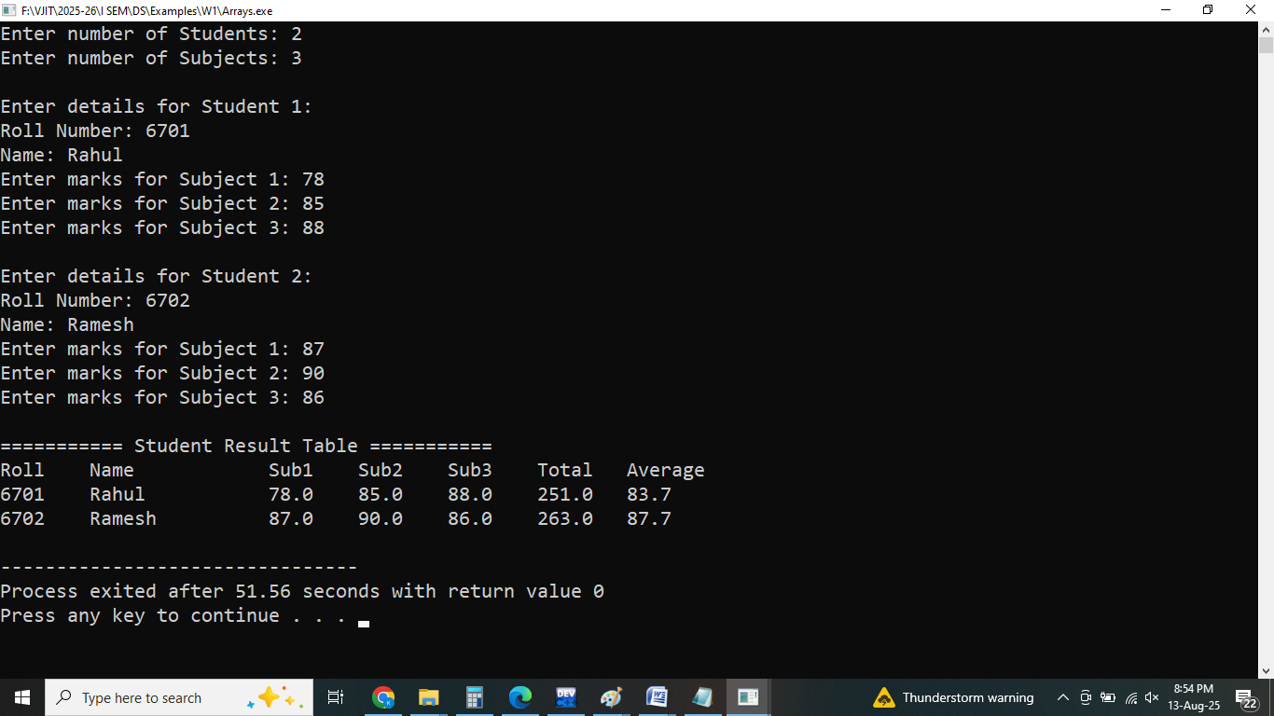

1. **C Programs to illustrate concepts of Structures to accept the Students Details along with their marks and generate the Result.**

#include <stdio.h>

*// Define student structure*

struct **Student**

{

int rollNumber;

char name[50];

float marks[10]; // Max 10 subjects

float total;

float average;

};

int **main**()

{

int numStudents, numSubjects;

int i, j;

printf("Enter number of Students: ");

scanf("%d", &numStudents);

printf("Enter number of Subjects: ");

scanf("%d", &numSubjects);

*// Declare array of structures*

struct Student students[numStudents];

*// Input student details*

for (i = 0; i < numStudents; i++)

{

printf("\nEnter details for Student %d:\n", i + 1);

printf("Roll Number: ");

scanf("%d", &students[i].rollNumber);

printf("Name: ");

scanf(" %[^\n]", students[i].name);

students[i].total = 0;

for (j = 0; j < numSubjects; j++)

{

printf("Enter marks for Subject %d: ", j + 1);

scanf("%f", &students[i].marks[j]);

students[i].total += students[i].marks[j];

}

students[i].average = students[i].total / numSubjects;

}

*// Print result table*

printf("\n============= STUDENT RESULT ==================\n");

printf("Roll\tName\t\t");

for (j = 0; j < numSubjects; j++)

{

printf("Sub%d\t", j + 1);

}

printf("Total\tAverage\n");

for (i = 0; i < numStudents; i++)

{

printf("%d\t%-10s\t", students[i].rollNumber, students[i].name);

for (j = 0; j < numSubjects; j++)

{

printf("%.1f\t", students[i].marks[j]);

}

printf("%.1f\t%.2f\n", students[i].total, students[i].average);

}

return 0;

}

**Output:**

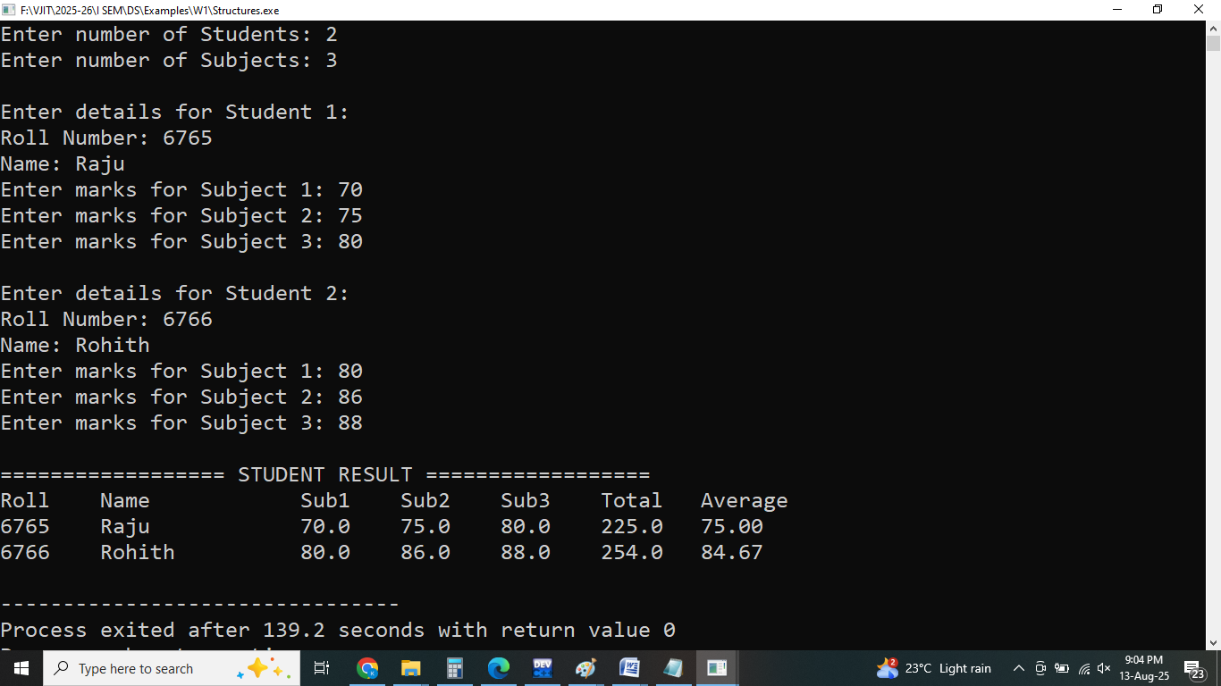

1. **C Programs to illustrate concepts of Unions to accept the Students Details along with their marks and generate the Result.**

#include <stdio.h>

*// Union for marks (max 10 subjects)*

union **Marks**

{

float subjects[10];

};

*// Student structure containing a union*

struct **Student**

{

int rollNumber;

char name[50];

union Marks m;

float total;

float average;

};

int **main**()

{

int numStudents, numSubjects;

int i, j;

printf("Enter number of Students: ");

scanf("%d", &numStudents);

printf("Enter number of Subjects: ");

scanf("%d", &numSubjects);

struct Student students[numStudents];

*// Input student details*

for (i = 0; i < numStudents; i++)

{

printf("\nEnter details for Student %d:\n", i + 1);

printf("Roll Number: ");

scanf("%d", &students[i].rollNumber);

printf("Name: ");

scanf(" %[^\n]", students[i].name);

students[i].total = 0;

for (j = 0; j < numSubjects; j++)

{

printf("Enter marks for Subject %d: ", j + 1);

scanf("%f", &students[i].m.subjects[j]);

students[i].total += students[i].m.subjects[j];

}

students[i].average = students[i].total / numSubjects;

}

// Print result table

printf("\n======= STUDENT RESULT ==================\n");

printf("Roll\tName\t\t");

for (j = 0; j < numSubjects; j++)

{

printf("Sub%d\t", j + 1);

}

printf("Total\tAverage\n");

for (i = 0; i < numStudents; i++)

{

printf("%d\t%-10s\t", students[i].rollNumber, students[i].name);

for (j = 0; j < numSubjects; j++)

{

printf("%.1f\t", students[i].m.subjects[j]);

}

printf("%.1f\t%.2f\n", students[i].total, students[i].average);

}

return 0;

}

**Output:**

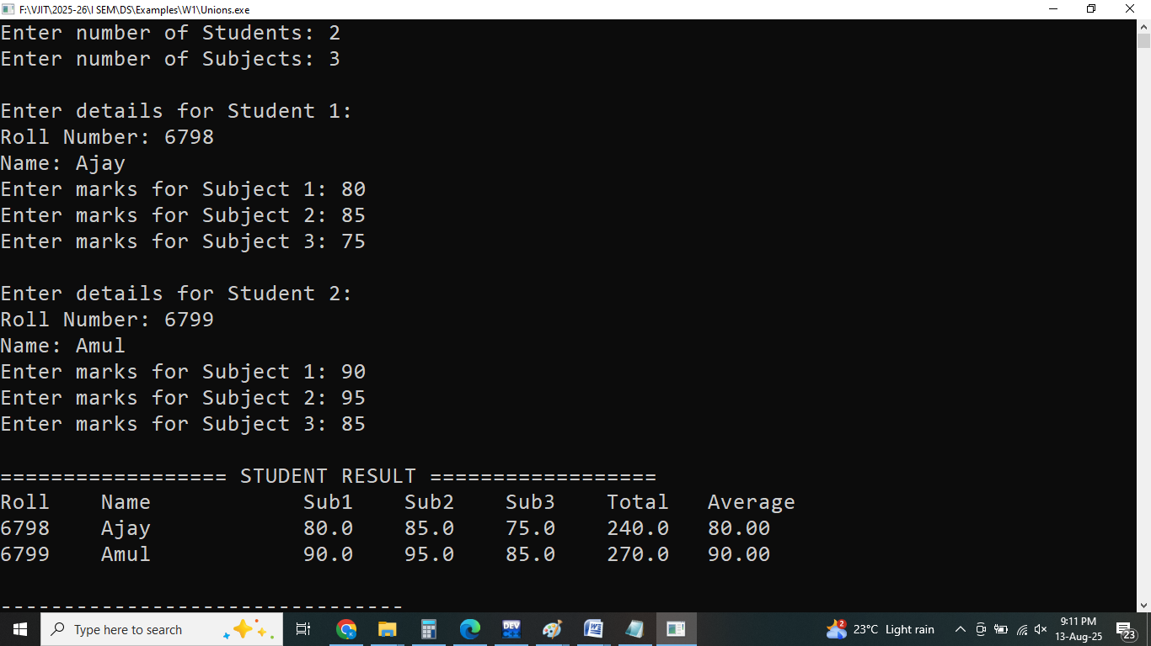

1. **C Programs to illustrate concepts of Enum Datatype to accept the Students Details along with their marks and generate the Result.**

#include <stdio.h>

#include <string.h>

*// Enum for subjects*

enum **Subjects**

{

DS,

DBMS,

PS,

MFCS,

CSA,

QMLR,

MAX_SUBJECTS

};

*// Structure for student*

struct **Student**

{

int rollNumber;

char name[50];

float marks[MAX_SUBJECTS];

float total;

float average;

};

int **main**()

{

int numStudents;

int i, subj;

printf("Enter number of Students: ");

scanf("%d", &numStudents);

struct Student students[numStudents];

// Input details

for (i = 0; i < numStudents; i++)

{

printf("\nEnter details for Student %d:\n", i + 1);

printf("Roll Number: ");

scanf("%d", &students[i].rollNumber);

printf("Name: ");

scanf(" %[^\n]", students[i].name);

students[i].total = 0;

*// Marks entry using enum*

for (subj = DS; subj < MAX_SUBJECTS; subj++)

{

switch (subj)

{

case DS:

printf("Enter marks for DS: ");

break;

case DBMS:

printf("Enter marks for DBMS: ");

break;

case PS:

printf("Enter marks for PS: ");

break;

case MFCS:

printf("Enter marks for MFCS: ");

break;

case CSA:

printf("Enter marks for CSA: ");

break;

case QMLR:

printf("Enter marks for QMLR: ");

break;

}

scanf("%f", &students[i].marks[subj]);

students[i].total += students[i].marks[subj];

}

students[i].average = students[i].total / MAX_SUBJECTS;

}

*// Print table*

printf("\n============ STUDENT RESULT ==============\n");

printf("Roll\tName\t\tDS\tDBMS\tPS\tMFCS\tCSA\tQMLR\tTotal\tAverage\n");

for (i = 0; i < numStudents; i++)

{

printf("%d\t%-10s\t", students[i].rollNumber, students[i].name);

for (subj = DS; subj < MAX_SUBJECTS; subj++)

{

printf("%.1f\t", students[i].marks[subj]);

}

printf("%.1f\t%.2f\n", students[i].total, students[i].average);

}

return 0;

}

**Output:**

